Company_____________________________________ Contact_________________________________
Address______________________________________ Phone___________________________________
City, State, Country_____________________________ Fax_____________________________________
Zip Code _____________________________________ E-mail___________________________________

Belt Scale Accuracy (%) __________________________________________________________________
Conveyor Belt Width ___________________ Max Belt Speed (Ft./Min)____________________________
Normal Belt Capacity ___________________ Idler Spacing _____________ Idler Foot Pad ____________

Please note any unique situations:

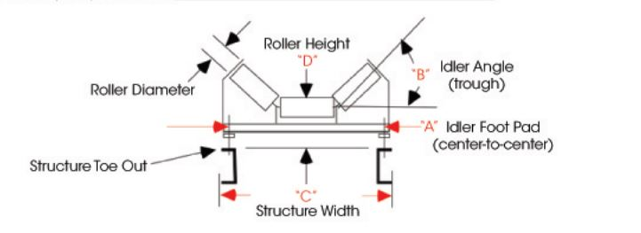
Return Fax: (877) 814-6306

